Name Date Period BioTechnology: Web Quest

Part 1 - Manipulating Genes
Go to http://www.dnai.org/b/index.html

Read the introduction. What were some questions scientists asked in the 1970’s regarding the genes in DNA?
- Questions
Could there be some kind of molecular editing system?
What tools could be devised to work with genes?
Could scientist then create tailored DNA molecules?

Click on Revolution
Summarize the problem
- Summary of problem

Each chromosome is a DNA molecule that can be thousands of base pairs long. The length created a problem for scientists that wanted to study the stretches of DNA that make up genes. If scientist want to go through and rewrite the “book or life,” they would need a mechanism to make the text manageable. They had to figure out how to isolate the DNA and how to cut, paste and copy DNA.

Click on Pieces of the Puzzle (top menu bar)
Learn about each piece of the puzzle by clicking on it. Read the text and view the animations. Summarize what you have learned. You do not have to go in the order listed below.

- Restriction Enzymes -

To work with an individual gene, scientist had to find a way to isolate the gene from the rest of the DNA around it. The discovery of restriction endonucleases gave the scientist the “molecular scissors” they needed.

- DNA ligation -

Arthur Kornberg identified an enzyme he called ligase allowed scientist to paste the ends of DNA together.

- The First Recombinant DNA -

Cohen and Boyer recombined genes from different bacteria into one DNA molecule. They used genes from two drug-resistant strains of E Coli, one provided resistance to the antibiotic, and the other resisted kanamycin.

- DNA Transformation -

Before Boyer and Cohen could isolate the recombinant plasmid, they needed a way to get their ligated plasmid into E Coli. Experiments by Oswald Avery and his group showed that pneumococcus bacteria are transformed to virulence when they take up DNA from strains.
Click on Techniques (bottom of page) Click on Cutting & Pasting (top of page)

Click on the Cutting & Pasting DNA button. Read the text and view the video.

- Make 3 sketches; a) Before DNA is cut b) After it is cut, and c) after it is pasted together. (Include nitrogen bases and which type of enzyme is used at each stage.)

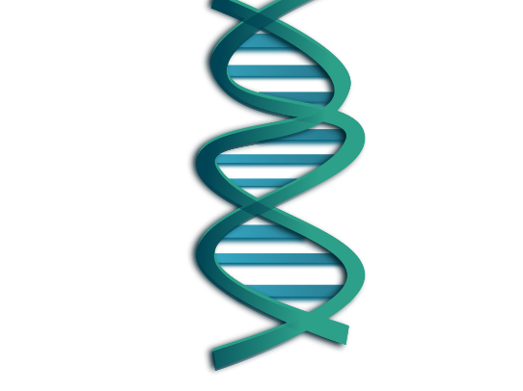
a) 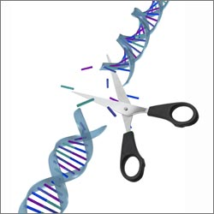b) c)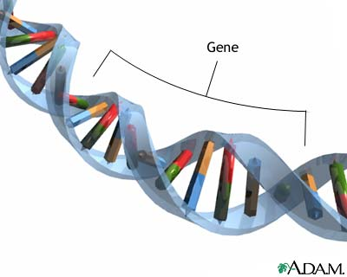

Click on Recombining DNA. Read the text and view the video

- What is a plasmid? a genetic structure in a cell that can replicate independently of the chromosomes,

What organisms have plasmids?

Bacteria

- Summarize the technique developed in the 1970’s in which a DNA fragment is added to a plasmid.

Researchers first inserted a foreign DNA fragment into a loop of bacterial DNA, called a plasmid.

- Check out the interviews with the scientists that made these discoveries.

- If you are interested continue with the other techniques involved in manipulating DNA.

Part 2 – Gel Electrophoresis
Go to http://www.tvdsb.on.ca/westmin/science/sbioac/genetics/Electro.htm
Read the introduction and the 3 main points of gel electrophoresis. Run the animations.
- The DNA is being cut into fragments by __________________________________

- Where are the fragments transferred? ___________________________________

3. What goes through the gel that creates a negative charge on one end (cathode) of the
gel box and a positive charge (anode) on the other end of the gel box?

4.What charge does the DNA fragments have? ____________________.

5. If you place the DNA on the negative side of the gel box it will be attracted to the ….?

6. What do you think happens if the DNA fragments are all different sizes (with different
weights) as they move through the gel?

Part 3 – DNA Fingerprinting (an application of biotechnology)
Go to http://www.pbs.org/wgbh/nova/sheppard/analyze.html
In this section you will solve a “crime” by doing a “DNA fingerprint” found at the crime scene
and comparing it to the “DNA fingerprints” of several suspects. By comparing the DNA from
the crime scene with the suspects’ DNA you will find the “criminal”.
Read the introduction then proceed through parts 1, 2, & 3. Do the simulated procedure.
Which sister committed the crime? _______________Honey___________________.

Part 4 Applications Go to http://www.dnai.org/d/index.html

You have already investigated one application of biotechnology in the above “fingerprinting”
activity. In this section other applications of the technology are explained. Choose between the
Genes & Medicine or the Human Origins modules and explore it. Pick an area of interest for you
in either module and write a short paragraph about it. What did you learn?

Humans are the only hominids left, our closest relative is a chimpanzee. The major adaptation of the hominid branch of our family tree is the ability to walk on two legs. Fifty thousand years ago, Neanderthals were our closest relative, but they are extinct, they were the first fossil recognized as humans, but they were different that our species. The only thing that spareates us apart is our behavior. Based on the fossil record, scientist learned that Neandertals possessed basic sounds similar to humans. Some researchers believe that Neandertals did bury their dead, and decorated the graves with ochres and flowers. We are the only survivors of our family tree.

