Text Comparison Matrix
Concept/subject: Mendel’s 4 Laws

Type of Mutation | Explanation | Example
Rule of Unit Factors | each organism has 2 alleles that control each trait | 1 alleles that come from mom and 1 allele that comes from dad
Rule of Dominance | In cases in which 2 or more alleles for a single trait exist, one allele may be dominant (mask) to the recessive one | Dominant = TT or Tt  Recessive = tt
Law of Segregation | each gamete receives 1 allele, during fertilization the gametes randomly pair resulting in 4 possible combinations | 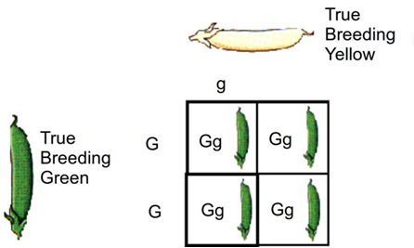
Law of Independent Assortment | the genes for different traits separate into gametes independently of each other | Genes for seed shape and seed color are inherited independently each other
Summary:

